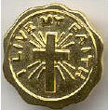

Catholic Committee on Scouting - Diocese of Nashville

I Live My Faith Workshop
for Girl Scouts ages 9 - 11

July 26, 2008
9 a.m. until 3 p.m.
Doors open at 8:30

St Matthew Catholic Church
535 Sneed Road West, Franklin, TN 37069

One time fee: $12.00 per girl
(fee includes book, supplies, snacks)
Bring your own sack lunch

Space is limited - Registration closes July 7th

For more information, contact
ChristineBesand
cbesand@comcast.net

